February 17, 2016
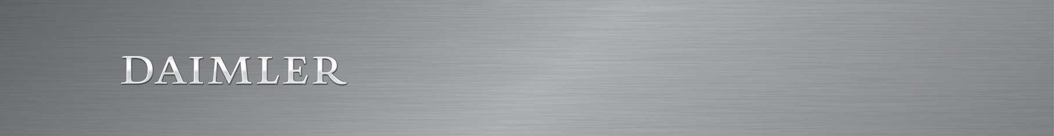
Daimler Sets Course for the Future: Supervisory Board Extends Dieter Zetsche's Contract
- Contract Extension until December 31, 2019
- Manfred Bischoff, Chairman of the Supervisory Board: "Daimler is more successful than ever. This proves that Dieter Zetsche pursues and implements the right strategy not only aligned with the supervisory board. He also can inspire Daimler’s employees for the demanding goals of the group. With the contract extension we are securing the continuity at the top needed for sustainable success."

Stuttgart, Germany – In its meeting today, the Supervisory Board of Daimler AG extended the contract of Dieter Zetsche (62) by three years until December 31, 2019. He will remain Chairman of the Board of Management of Daimler AG and Head of Mercedes-Benz Cars until that date.
"Daimler is more successful than ever. This proves that Dieter Zetsche pursues and implements the right strategy not only aligned with the supervisory board. He also can make employees enthusiastic for the demanding targets of the group. With the contract extension we are securing the continuity at the top needed for sustainable success", said Manfred Bischoff, Chairman of the Supervisory Board of Daimler AG. "We are looking forward to continuing the excellent collaboration with Dieter Zetsche."
Dieter Zetsche has been a member of the Board of Management since December 16, 1998 and Chairman of the Board of Management of Daimler AG since January 1, 2006. In addition, he is Head of the Mercedes-Benz Cars Division. The contract of Dieter Zetsche would have run out on December 31, 2016. Manfred Bischoff, Chairman of the Supervisory Board, had already announced that the Supervisory Board would like to extend Dieter Zetsche's contract at the Annual Shareholders Meeting
on April 1, 2015.
Dieter Zetsche's curriculum vitae is available under:
http://www.daimler.com/company/corporate-governance/board-of-management/zetsche/
Contacts:
Jörg Howe, + 49 711 17-41341, joerg.howe@daimler.com
Hendrik Sackmann, + 49 711 17-35014, hendrik.sackmann@daimler.com
Further information about Daimler is available online: www.media.daimler.com and www.daimler.com

Daimler at a glance
Daimler AG is one of the world’s most successful automotive companies. With its divisions Mercedes-Benz Cars, Daimler Trucks, Mercedes-Benz Vans, Daimler Buses and Daimler Financial Services, the vehicle manufacturer is one of the biggest providers of premium cars and the world's biggest manufacturer of commercial vehicles with a global reach. Daimler Financial Services offers financing, leasing, fleet management, insurance, financial investments, credit cards, and innovative mobility services.
The company’s founders, Gottlieb Daimler and Carl Benz, made history with their invention of the automobile in 1886. As an automotive pioneer, Daimler continues to shape the future of mobility. The company's focus is on innovative and green technologies and safe and superior vehicles that captivate and inspire customers. Daimler invests systematically in the development of alternative drive systems — ranging from hybrid vehicles to all-electric vehicles powered by a battery or a fuel cell — with the goal of making emission-free driving possible in the long term. In addition, the company is fully committed to accident-free driving, intelligent networking, and autonomous driving. This is because Daimler considers it a challenge and an obligation to meet its responsibility towards society and the environment. Daimler sells its vehicles and services in almost every country in the world and has production facilities in Europe, North and South America, Asia, and Africa. Its brand portfolio includes the world's most valuable premium automotive brand, Mercedes-Benz, as well as Mercedes-AMG, Mercedes-Maybach and Mercedes me; the brands smart, Freightliner, Western Star, BharatBenz, FUSO, Setra, and Thomas Built Buses; and the Daimler Financial Services brands: Mercedes-Benz Bank, Mercedes-Benz Financial, Daimler Truck Financial, moovel, car2go and mytaxi. The company is listed on the stock exchanges of Frankfurt and Stuttgart (stock exchange symbol DAI). In 2015, the Group sold 2.9 million vehicles with a workforce of 284,015 employees. According to preliminary and unaudited figures revenue totalled €149.5 billion and EBIT amounted to €13.2 billion.

